

Reverse Engineering of a Servo Amplifier

(The SA150D from FeedBack)

*EEE3000X*

*By Tanyaradzwa Chinyai*

# Contents

Objective 2

Equipment and Principles 2

Method and Results 2

Conclusions and Recommendations 4

Appendix A 4

Terminal Connections 5

Resistor Connections 6

Capacitor Connections 6

Transistor Connections 7

Diode connections 7

IC Connections 7

# Objective

I was tasked with reverse engineering the SA150D, a servo amplifier used to operate motors in motor-tacho unit configurations. This report is a recount of the process that I took in order to accurately re-create the amplifier and the progress that I made towards a functioning duplicate.

# Equipment and Principles

The abstract electrical circuit of the Servo amplifier is shown below in *Figure 1*.

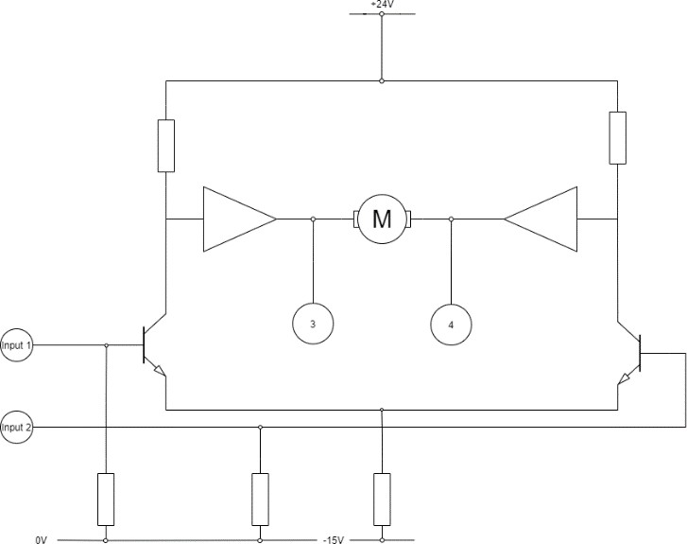

*Figure 1: The Servo Amplifier Circuit*

Inside the housing of the SA150D is a printed circuit board that consists of 95 electronic components (resistors, transistors, potentiometers, capacitors, etc) all connected with **two** copper layers (one on the *top side* of the PCB and another on the *bottom side*). Careful analysis of the PCB showed that it had no copper layer/s inside the PCB.

The main challenge was to extrapolate a schematic of the full circuit from the PCB. The equipment and programs I used to do this were:

* A digital camera (my phone’s camera was sufficient)
* Photoshop – used for general brushing of the initial image and adding of the components after preliminary editing.
* Inkscape – used to create a vector graphic of the circuit image for a clearer view and for easier editing.
* eeschema in kiCad – To recreate the circuit from the images (to increase accuracy and correctness)

# 

# Method and Results

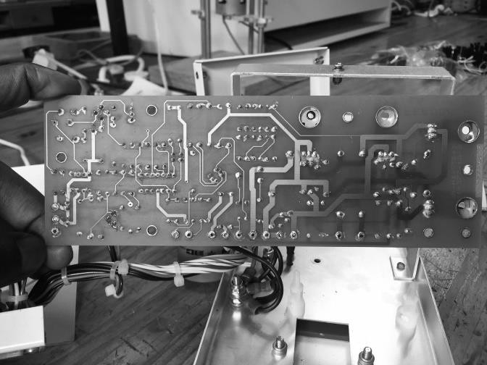The process of recreating the Servo Amplifier began by taking a black and white image of the *bottom side* of the PCB as shown in *Figure 2*.

*Figure 2: An image of the bottom side of the PCB.*

On this image, I used photoshop to brush the image of spots that were indistinguishable from the copper layer such as overlapping solder, paint, or insulation. The brushed image was also cropped it to show the just the PCB and the connections. The result of the brushing is shown in *Figure 3 below.*

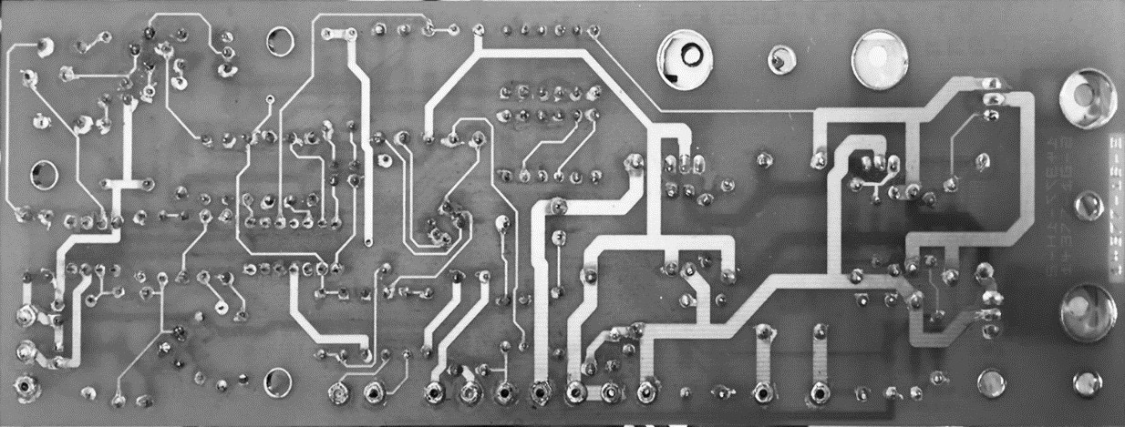

*Figure 3 Brushed image of the PCB.*

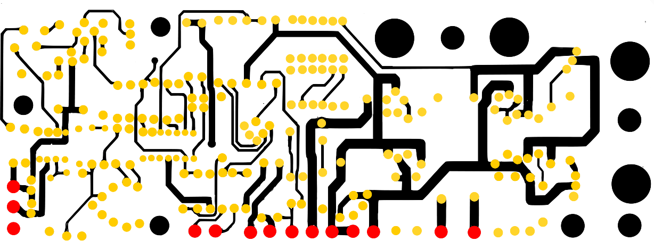Inkscape was then used to convert the brushed image into a vector graphic showing the copper layer only and to mark the different types of holes. Additionally, I put the image back into photoshop for more brushing to make the tracings established by Inkscape exactly like the bottom side connections on the PCB. *Figure 4* shows the outcome of the edit.

*Figure 4: The bottom side copper connections.*

On *Figure 4* the circles represent the Non-Plated Through Holes in which the components are soldered into. The yellow circles are for the components, the black holes represent through holes with no connections or ground holes and the red circles represent terminal that connect using wire to power sources and other unsoldered components on the PCB.

The components were then placed on to this image (*Figure 4)* corresponding to their positions on the topside of the board. *Figure 5* shows this result of the placement:

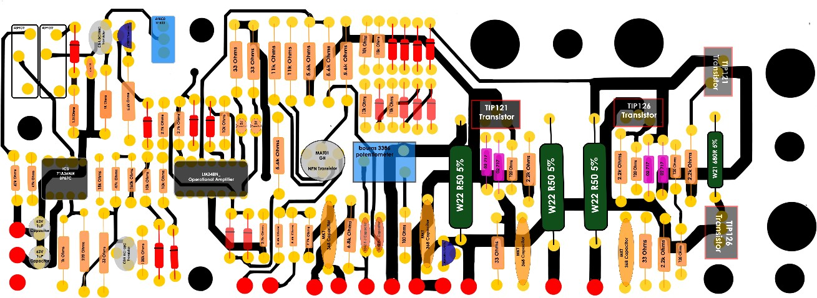

*Figure 5: Components connected to the bottom copper connections.*

The components are labelled carefully, and the data sheets for the ICs and similar components are available on this [drive](https://drive.google.com/drive/folders/1DkLnfita8eOmM__ZF8UDO9cBNCc4jrgw?usp=sharing). At this stage I used eeschema within kiCad to draw the connections of the components more clearly. This [Link](https://drive.google.com/file/d/1CjQaB4xZkmJUTdkQ73bZ18QBgtmyjWGm/view?usp=sharing)  goes to an eeschema file that contains two circuits that describe the topside and bottom side connections on the PCB.

Moreover, I established a list of the combined connections on the circuit. I used the labels of the components on the PCB to keep track of the components. The list describes the components and how the terminals should be connected. *Table 2* in Appendix A shows these connections.

Additionally, an eeschema circuit was connected. Showing all the connections to the components. (Disclaimer: The circuit requires 3-4 more iterations, reconnecting the terminals to make it more accurate. This version is bound to have errors or unconnected terminals.) This [link](https://drive.google.com/file/d/1Gwaxh3DKpGOvoIftUmdpmqyxk54O39Dh/view?usp=sharing) goes to a folder that contains an eeschema file that has the fully connected PCB of the SA150D Servo amplifier, which excludes the connections on the AV terminals, and other LTSpice files that attempt to recreate the amplifier connections within the PCB, in order to simulate. LTSpice however did not have many of the component models found on the PCB.

# Conclusions and Recommendations

The connections between the PCB components were successfully established as shown in Appendix

A. The next step in the process of recreating the servo amplifier is to place the suggested components (or equivalent components) on a breadboard and then proceed to test it.

# Appendix A

*Table 1 Component labels and descriptions*

|  |  |
| --- | --- |
| **LABEL** | **COMPONENT** |
| **RESISTORS (R LABELS)** | |
| **R3** | W21R 680R 5% - The datasheet for this component was especially difficult to find – It resistance can be measured directly however. |
| **R5, R23, R24** | W22 R50 5% - (Same as R3) |
| **R37, R30** | 43 P102 Resistive [Trimmer](https://drive.google.com/file/d/1dW5VlCW0NvM-EQ7f83Kn6gyh6b51oNh9/view?usp=sharing) |
| **R15, R29** | 1 kΩ |
| **R40, R42, R46, R47** | 120 Ω |
| **R9** | 220 Ω |
| **R8, R20, R21, RRR, R25** | 33 Ω |
|  |  |
| **R27** | 100 Ω |
| **R38, R13, R10** | 47 kΩ |
| **R32** | 1.5 kΩ |
| **R41, R43, R45, R44,** | 2.2 kΩ |
| **R1, R7, R48, R53** | 2.7 kΩ |
| **R2, R6, R14, R16, R17, R18, R19** | 5.6 kΩ |
| **R4** | 6.8 kΩ |
| **R33, R34** | 11 kΩ |
| **R12, R50, R51** | 18 kΩ |
| **R35, R36, R22, R49, R52** | 10 kΩ |
| **R39** | 100 kΩ |
| **R11** | 160 kΩ |
| **DIODES (D LABELS)** | |
| **D1- D8 & D13 -D20** | BAW62 [Diode](https://drive.google.com/file/d/1MHWqsj9pouWRHv5mX92EInBwx5qBDBFk/view?usp=sharing) |
| **D9 – D12** | 002 717 – *unclear*   * *Black and Silver Diodes with marking 002 717. E.ge ones sold at* [*Vishay electronics*](https://za.rs-online.com/web/p/switching-diodes/8119893/?cm_mmc=ZA-PLA-DS3A-_-google-_-PLA_ZA_EN_Semiconductors_Whoop-_-(ZA:Whoop!)+Switching+Diodes-_-8119893&matchtype=&aud-826607885227:pla-337620848293&gclid=CjwKCAiAksyNBhAPEiwAlDBeLKKXfvv3h_Ze3y94JgIrHVdAYHsUVyf7S8DPSzDxj84qDJ1HS4v0QxoCAcQQAvD_BwE&gclsrc=aw.ds)*.* |
| **CAPACITORS (C LABELS)** | |
| **C3, C4 & C8** | 47nF Capacitors |
| **C5, C6, C9, C10** | [MKT368](https://drive.google.com/file/d/1lX6MwYvxKQnFXqohdzze-3uB5UNiREwR/view?usp=sharing) film Capacitors |
| **C2, C7** | 100nF Capacitor |
| **C11 & C12** | 1uF 63V Capacitor |
|  |  |
| **TRANSISTORS (TR LABELS)** | |
| **TR1 & TR8** | [C557](https://drive.google.com/file/d/17sWyB7ITVmpNaI3InpT87MaUsYgmUlPX/view?usp=sharing) Amplifier transistor |
| **TR2 & TR3** | [BC108](https://drive.google.com/file/d/1tzVfH0oKE_H8Um8lI9S2lr4YLAuxHYpN/view?usp=sharing) NPN Planar transistor |
| **TR4 & TR6** | [TIP121](https://drive.google.com/file/d/11VfL2jWFJLIC4sG9gn0gTYndHkW9r4H0/view?usp=sharing) Transistors |
| **TR5 & TR7** | [TIP126](https://drive.google.com/file/d/1Y8HXK64RybaIWEPK7xEDkPt7uWM7Lsyo/view?usp=sharing) Transistors |
| **TERMINALS (AV LABELS)** | |
| **AV1** | *Input* |
| **AV2** | *Input* |
| **AV3** | *Control Voltage monitor* |
| **AV4** | *Control Voltage monitor* |
| **AV5 – AV12** | *Needs More Analysis* |
| **AV13 & AV14** | Terminals to [Electrolytic Capacitor](https://drive.google.com/file/d/11XpGTqaraJBAJoku6-C724DLklbcSmns/view?usp=sharing) |
| **ICS (IC LABELS)** | |
| **IC1** | LM348N Operational [amplifier](https://drive.google.com/file/d/10dzGCV1tgrkecBx_Hh1mopVO6xpiiUVF/view?usp=sharing) |
| **IC2** | MAT01 Monolithic dual [transistor](https://drive.google.com/file/d/1IHSsHBjPWe22vNpeipl559H5d7HO8iD5/view?usp=sharing) |
| **IC3** | 0P07C Voltage operational [amplifier](https://drive.google.com/file/d/1XKaQbel6khooeh7dF1WbL14CAScuhmC1/view?usp=sharing) |
| **GND** | Hole Punch that connects wires from the bottom fac of the PCB to the Top Face of the PCB. |

*Table 2: Component connections*

|  |  |  |  |  |  |  |  |  |  |  |  |  |  |
| --- | --- | --- | --- | --- | --- | --- | --- | --- | --- | --- | --- | --- | --- |
| ***Resistor Connections*** | | | | | | | | | | | | | |
| R1(1) 🡪 C9(2)   * R7(1) | | | | R1(2) 🡪 IC2(5)   * R2(2) | | | | | | | | | |
| R2(1) 🡪 AV2 | | | | R2(2) 🡪 R1(2) | | | | | | | | | |
| R3(1) 🡪 TR7(3)   * D11(2) | | | | R3(2) 🡪 TR5(3) | | | | | | | | | |
| R4(1) 🡪 C2(1)   * AV9 | | | | R4(2) 🡪 AV8   * R39(2) | | | | | | | | | |
| R5(1) 🡪 TR8(3)   * AV14 * D10(1) * R43(1) * TR5(2) * R44(2) * TR7(2) * D12(1) | | | | R5(2) 🡪 R28(1) | | | | | | | | | |
| R6(1) 🡪 AV1 | | | | R6(2) 🡪 R7(2)   * IC2(2) | | | | | | | | | |
| R7(1) 🡪 R1(1) | | | | R7(2) 🡪 R6(2)   * IC1(11) | | | | | | | | | |
| R8(1) 🡪 C12(2) | | | | R8(2) 🡪 TR2(3)   * R10(1) * R9(1) | | | | | | | | | |
| R9(1) 🡪 R8(2)   * R9(1) * TR2(3) | | | | R9(2) 🡪 IC3(6)   * R15(2) | | | | | | | | | |
| R10(1) 🡪 TR2(3)   * R8(2) * R9(1) | | | | R10(2) 🡪 R11(2)   * IC3(2) | | | | | | | | | |
| R11(1) 🡪 R35(2) | | | | R11(2) 🡪 R10(2) | | | | | | | | | |
| R12(1) 🡪 C5(1) | | | | R12(2) 🡪 R37(3) | | | | | | | | | |
| R13(1) 🡪 R38(1)   * IC1(13) * IC1(12) * IC1(11) * R21(1) | | | | R13(2) 🡪 R38(2)   * IC1(11) | | | | | | | | | |
| R14(1) 🡪 R17(1)   * D18(1) | | | | R14(2) 🡪 R18(1)   * TR6(3) * IC1(4) | | | | | | | | | |
|  | | | |  | | | | | | | | | |
| R15(1) 🡪 AV5 | | | | R15(2) 🡪 IC3(6) | | | | | | | | | |
| R16(1) 🡪 IC1(5)   * IC2(1) | | | | R16(2) 🡪 R18(1) | | | | | | | | | |
| R17(1) 🡪 R14(1)   * R18(1) | | | | R17(2) 🡪 TR1(3) | | | | | | | | | |
| R18(1) 🡪 R16(2)   * R17(1) * R14(2) * TR4(2) * IC1(4) | | | | R18(2) 🡪 R19(2)   * IC1(3) | | | | | | | | | |
| R19(1) 🡪 R22(1)   * C7(1) | | | | R19(2) 🡪 R18(2) | | | | | | | | | |
| R20(1) 🡪 C3(2) | | | | R20(2) 🡪 R21(2) | | | | | | | | | |
| R21(1) 🡪 C4(2) | | | | R21(2) 🡪 R20(2)   * GND | | | | | | | | | |
| R22(1) 🡪 R19(1) | | | | R22(2) 🡪 D1(2) | | | | | | | | | |
| R23(1) 🡪 AV12 | | | | R23(2) 🡪 D10(2)   * TR5(3) | | | | | | | | | |
| R24(1) 🡪 AV11 | | | | R24(2) 🡪 D14(2) | | | | | | | | | |
| R25(1) 🡪 | | | | R25(2) 🡪 AV14   * C6(2) | | | | | | | | | |
| R26(1) 🡪 | | | | R26(2) 🡪 | | | | | | | | | |
| R27(1) 🡪 C7(1)   * C10(1) | | | | R27(2) 🡪 R28(3) | | | | | | | | | |
| R28(1) 🡪 AV10   * R5(2) | | | | R28(2) 🡪 C2(2) | | | | | R28(3)🡪 R27(2) | | | | |
| R29(1) 🡪 C8(1)   * R32(1) | | | | R29(2) 🡪 TR3(1) | | | | | | | | | |
| R30(1) 🡪 D2(2) | | | | R30(2) 🡪 TR1(3)   * C8(2) | | | | | | | | | |
| R31(1) 🡪 R34(2) | | | | R31(2) 🡪 R33(2)   * TR3(3) | | | | | | | | | |
| R32(1) 🡪 R29(1)   * IC3(4) | | | | R32(2) 🡪 D2(1) | | | | | | | | | |
| R33(1) 🡪 IC2(3) | | | | R33(2) 🡪 R31(2) | | | | | | | | | |
| R34(1) 🡪 IC2(4) | | | | R34(2) 🡪 R31(1) | | | | | | | | | |
| R35(1) 🡪 D20(2) | | | | R35(2) 🡪 D8(1)   * R11(1) * R51(1) | | | | | | | | | |
| R36(1) 🡪 D19(2) | | | | R36(2) 🡪 IC3(4) | | | | | | | | | |
| R37(1) 🡪 R38(2)   * IC3(3) | | | | R37(2) 🡪 | | | R37(3)🡪 R12(2) | | | | | | |
| R38(1) 🡪 AV6   * R13(1) | | | | R38(2) 🡪 R37(1)   * R13(2) | | | | | | | | | |
| R39(1) 🡪TR2(1) | | | | R39(2) 🡪C11(2)   * R4(2) | | | | | | | | | |
| R40(1) 🡪 IC1(7) | | | | R40(2) 🡪 R41(2)   * TR4(1) | | | | | | | | | |
| R41(1) 🡪 D11(1)   * D9(1) | | | | R41(2) 🡪 R41(2) | | | | | | | | | |
| R42(1) 🡪 IC1(7) | | | | R42(2) 🡪 R43(2)   * TR5(1) | | | | | | | | | |
| R43(1) 🡪 AV14   * D12(1) | | | | R43(2) 🡪 R42(2) | | | | | | | | | |
| R44(1) 🡪 R47(1) | | | | R44(2) 🡪 TR7(2)   * D12(1) | | | | | | | | | |
| R45(1) 🡪 TR6(2)   * D11(1) | | | | R45(2) 🡪 R46(2)   * TR6(1) | | | | | | | | | |
| R46(1) 🡪 R47(2) | | | | R46(2) 🡪 R45(2) | | | | | | | | | |
| R47(1) 🡪 R44(1)   * TR7(1) | | | | R47(2) 🡪 IC1(8)   * R46(1) | | | | | | | | | |
| R48(1) 🡪R53(1)   * IC1(1) | | | | R48(2) 🡪GND   * D3(2) * IC1(9) | | | | | | | | | |
| R49(1) 🡪 GND | | | | R49(2) 🡪 R50(2) | | | | | | | | | |
| R50(1) 🡪 D13(2) | | | | R50(2) 🡪 R49(2)   * D16(2) | | | | | | | | | |
| R51(1) 🡪D8(1)   * R35(2) | | | | R51(2) 🡪D5(2)   * D6(2) | | | | | | | | | |
| R52(1) 🡪 IC1(6) | | | | R52(2) 🡪 D6(2) | | | | | | | | | |
| R53(1) 🡪 R48(1)   * D1(1) | | | |  | | | | | | | | | |
| ***Capacitor Connections*** | | | | | | | | | | | | | |
| C2(1) 🡪 TR8(1)   * R4(1) | | | | C2(2) 🡪 C7(2)   * R28(2) | | | | | | | | | |
| C3(1) 🡪 IC1(7) | | | | C3(2) 🡪 R20(1) | | | | | | | | | |
| C4(1) 🡪 IC1(8) | | | | C4(2) 🡪 R21(1) | | | | | | | | | |
| C5(1) 🡪 AV11   * R12(1) | | | | C5(2) 🡪 RRR(2) | | | | | | | | | |
| C6(1) 🡪 AV12 | | | | C6(2) 🡪 R25(2) | | | | | | | | | |
| C7(1) 🡪 R27(1)   * R19(1) | | | | C7(2) 🡪 C2(2)   * TR8(2) | | | | | | | | | |
| C8(1) 🡪 R29(1) | | | | C8(2) 🡪 R30(2)   * TR3(2) | | | | | | | | | |
| C9(1) 🡪AV4 | | | | C9(2) 🡪R1(1) | | | | | | | | | |
| C10(1) 🡪 R27(1)   * TR8(3) | | | | C10(2) 🡪 AV3   * TR4(2) | | | | | | | | | |
| C11(1) 🡪 C12(2)   * AV6 | | | | C11(2) 🡪 R3992)   * IC3(4) | | | | | | | | | |
| C12(1) 🡪 AV6   * IC3(7) | | | | C12(2) 🡪 C11(1)   * R8(1) | | | | | | | | | |
|  | | | |  | | | | | | | | | |
| ***Transistor Connections*** | | | | | | | | | | | | | |
| TR1(1) 🡪 | | | | TR1(2) 🡪 D1(20 | | | | TR1(3) 🡪 R17(2)   * R30(2) | | | | | |
| TR2(1) 🡪 R39(1) | | | | TR2(2) 🡪 D20(1) | | | | TR2(3) 🡪 R9(1)   * R8(2) * R10(2) | | | | | |
| TR3(1) 🡪 R29(2) | | | | TR3(2) 🡪 C8(2) | | | | TR3(3) 🡪 R31(2) | | | | | |
| TR4(1) 🡪 R40(2) | | | | TR4(2) 🡪 R18(1)   * C10(2) * D9(1) | | | | TR4(3) 🡪R43(2)   * R42(2) | | | | | |
| TR5(1) 🡪R42(2) | | | | TR5(2) 🡪AV14 | | | | TR5(3) 🡪R23(2)   * R3(2) | | | | | |
| TR6(1) 🡪 R45(2) | | | | TR6(2) 🡪 R45(1) | | | | TR6(3) 🡪 D11(2)   * R14(2) | | | | | |
| TR7(1) 🡪R47(1) | | | | TR7(2) 🡪R44(2) | | | | TR7(3) 🡪 R3(1) | | | | | |
| TR8(1) 🡪 C2(1) | | | | TR8(2) 🡪 C7(2) | | | | TR8(3) 🡪 R5(1)   * C10(1) | | | | | |
|  | | | |  | | | | | | | | | |
| ***Diode Connections*** | | | | | | | | | | | | | |
| D1(1) 🡪 R53(1) | | | | D1(2) 🡪 TR1(2)   * R22(2) | | | | | | | | | |
| D2(1) 🡪R32(2) | | | | D2(2) 🡪R30(1) | | | | | | | | | |
| D3(1) 🡪D4(1) | | | | D3(2) 🡪R48(2) | | | | | | | | | |
| D4(1) 🡪D3(1)   * IC1(5) | | | | D4(2) 🡪IC1(6) | | | | | | | | | |
| D5(1) 🡪 D7(2) | | | | D5(2) 🡪 R51(2) | | | | | | | | | |
| D6(1) 🡪 D8(2) | | | | D6(2) 🡪 R51(2)   * R52(2) | | | | | | | | | |
| D7(1) 🡪 D9(2) | | | | D7(2) 🡪 D5(1) | | | | | | | | | |
| D8(1) 🡪 R35(2)   * R51(1) | | | | D8(2) 🡪 D6(1) | | | | | | | | | |
| D9(1) 🡪 R41(1)   * TR4(2) | | | | D9(2) 🡪 D7(1)   * D10(2) | | | | | | | | | |
| D10(1) 🡪RRR | | | | D10(2) 🡪D9(2)   * R23(2) | | | | | | | | | |
| D11(1) 🡪 R41(1)   * R45(1) | | | | D11(2) 🡪 TR6(3)   * D11(2) * R3(1) | | | | | | | | | |
| D12(1) 🡪 R43(1)   * R44(2) | | | | D12(2) 🡪D11(2) | | | | | | | | | |
| D13(1) 🡪D15(1) | | | | D13(2) 🡪 R50(1)   * D14(2) | | | | | | | | | |
| D14(1) 🡪 D16(1) | | | | D14(2) 🡪D13(2)   * R24(2) | | | | | | | | | |
| D15(1) 🡪D13(1) | | | | D15(2) 🡪D16(2) | | | | | | | | | |
| D16(1) 🡪D14(1) | | | | D16(2) 🡪D15(2)   * R50(2) | | | | | | | | | |
| D17(1) 🡪 D18(1) | | | | D17(2) 🡪 D18(2)   * IC1(90 | | | | | | | | | |
| D18(1) 🡪 D17(1)   * R14(1) | | | | D18(2) 🡪 D17(2) | | | | | | | | | |
| D19(1) 🡪D20(1) | | | | D19(2) 🡪 R36(1) | | | | | | | | | |
| D20(1) 🡪TR2(2)   * D19(1) | | | | D20(2) 🡪 R35(1) | | | | | | | | | |
| ***IC Connections*** | | | | | | | | | | | | | |
| IC1(1)🡪R48(1)  IC1(2)🡪 | IC1(3)🡪R18(2)  IC1(4)🡪R18(2)   * R14(2) | | IC1(5)🡪   * R16(1) * D4(1)   IC1(6)🡪R52(1)   * D4(2) | IC1(7)🡪C3(1)   * R42(1) * R40(1)   IC1(8)🡪R47(2)   * C4(1) | IC1(9)🡪D17(2)   * R48(2)   IC1(10)🡪IC2(6) | | | | | | IC1(11)🡪R7(1)   * R13(2) * IC1(12)   IC1(12)🡪   * IC1(11) * IC1(13) | | IC1(13)🡪 IC1(12)  IC1(14)🡪 |
| IC2(1)🡪R16(1)   * IC1(10) | IC2(2)🡪R6(2) | | IC2(3)🡪R33(1) | IC2(4)🡪R1(2)   * R34(1) | | IC2(5)🡪 | | | | | | IC2(6)🡪IC1(10) | |
| IC3(1)🡪  IC3(2)🡪R10(2) | | IC3(3)🡪R37(1)  IC3(4)🡪C11(2)   * R36(2) * R32(1) | | IC3(5)🡪  IC3(6)🡪R15(2)   * R9(2) | | | | | | IC3(7)🡪C12(1)  IC3(8)🡪 | | | |